Analysis and Design DATABASE
Table of Contents
1. Introduction .......................................................................................
1.1. Purpose of document .......................................................................
1.2. Scope ..............................................................................................
1.3. The reader is expected .....................................................................
1.4. References ......................................................................................
2. Describe the problem ..........................................................................
3. Functional Requirements .....................................................................
3.1. List users .........................................................................................
3.2. Identify requirements .......................................................................
4. Usecases model ..................................................................................
4.1. Usecases List ...................................................................................
4.2. Usecases model ...............................................................................
5. Database Diagram ..............................................................................
6. Logical data model ..............................................................................
7. Constraints business ...........................................................................
8. Glossary ...........................................................................................

1. Introduction
1.1 Purpose of document
- Help the reader understand:
- The function of each actor in the system.
- The type of data, relationships and constraints of such data in the system.
- The procedures and events in the database.

1.2 Scope
- System includes:
- Account Management
- Booking Room Management
- Statistic And Report
- Room Management
- Group Borrower Management
- Borrower Management
- Email Management
- Recycle Bin Management

1.3 The reader is expected
Participants develop the system

1.4 References
❖ SRS
❖ Use-case description

2. Describe the problem:
Faculty now has a number of meeting rooms for both faculty and students participate in the meeting, exchange and learning. Procedures of the rooms registration as follows:
- Teachers - Students wishing to enroll room: contact "Ms. Manh" to register rooms with a room, any time, for registration in the meeting room to do?
- “Ms. Manh” will check the registration list, if space is going for registration, otherwise you will not notice that the room is empty.
- "Ms Manh" can suggest the empty conference room to give them room and time change (if necessary).
However, there are difficulties when registering for the room, "Ms. Manh" is not in the office do not know any free room registered any room. Therefore, a software support help for displaying information of the registered office, office space for faculty members - students wishing to enroll will be easily seen.
- Software Requirements:
1. Show list of meeting rooms, changing colors for state office:
a. Availability (Green).
b. Registered Office (Yellow).
c. Rooms are using (Red).
2. Reservation.
3. Changing rooms.
4. Check out room.
5. Statistics on the use of room.

3. Functional Requirements:
3.1. List users:
❖ Admin
❖ Booking Room Management
3.2. Identify requirements

4. Usecase model
4.1. Usecase List
Use Case ID | Use Cases Name | Primary Actor
UC1 | Account Management | Administrator
UC1.1 | View Account List
UC1.2 | Create Account
UC1.3 | Search Account
UC1.4 | View Account
UC1.5 | Edit Account
UC1.6 | Delete Account
UC1.7 | Reset Password
UC1.8 | Reset Admin’s Password
UC1.9 | Edit Current Account
UC1.10 | View Current Account
UC1.11 | Sign In
UC1.12 | Sign Out
UC2 | Booking Room Management | Booking Room Manager
UC2.1 | Booking Room
UC2.2 | View Booking Room List
UC2.3 | Search Booking Room
UC2.4 | View Booking Room
UC2.5 | Change Booking Room
UC2.6 | Cancel Booking Room
UC2.7 | Check In
UC2.8 | Check Out
UC2.9 | View Conflict List
UC2.10 | Resolve Conflict
UC2.11 | Resolve Conflict Automatically
UC3 | Statistic And Report | Booking Room Manager
UC3.1 | Export Report
UC3.2 | View Statistic
UC3.3 | Log Record
UC4 | Room Management | Booking Room Manager
UC4.1 | View Room List
UC4.2 | Create Room
UC4.3 | Search Room
UC4.4 | View Room
UC4.5 | Edit Room
UC4.6 | Delete Room
UC5. | Group Borrower Management | Booking Room Manager
UC5.1 | View Group Borrower List
UC5.2 | Create Group Borrower
UC5.3 | View Group Borrower
UC5.4 | Edit Group Borrower
UC5.5 | Delete Group Borrower
UC6. | Borrower Management | Booking Room Manager
UC6.1 | View Borrower List
UC6.2 | Create Borrower
UC6.3 | Import Borrower List
UC6.4 | Search Borrower
UC6.5 | View Borrower
UC6.6 | Edit Borrower
UC6.7 | Edit Violation
UC6.8 | Delete Borrower
UC6.9 | View Violation List
UC7 | Email Management | Booking Room Manager
UC7.1 | View Email Template List
UC7.2 | View Email Template
UC7.3 | Edit Email Template
UC7.4 | View Resend Email List
UC7.5 | Send Email Automatically
UC7.6 | Resend Email Automatically
UC8 | Recycle Bin Management | Administrator
UC8.1 | View Deleted Data List

4.2. Usecases model
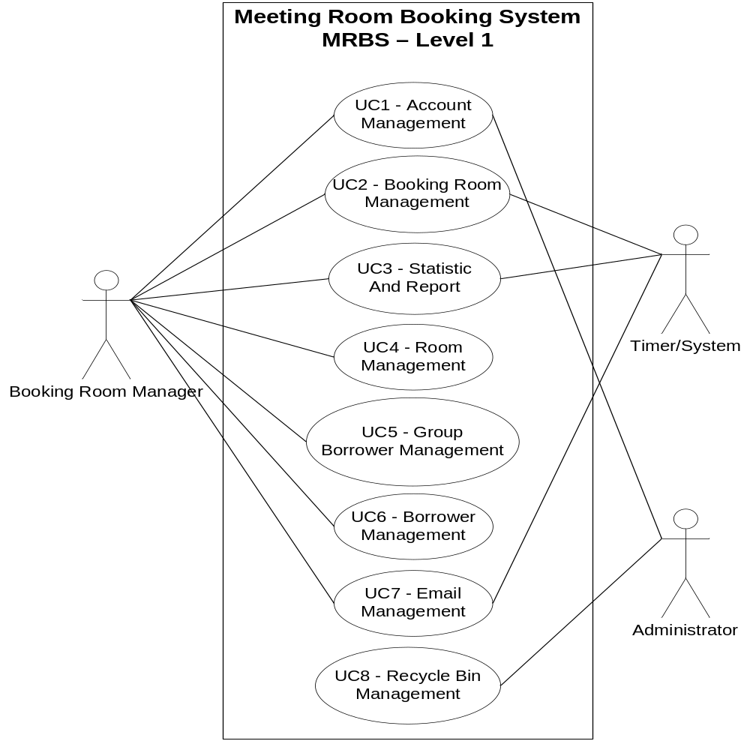
5. Database Diagram
